In addition to the manufacturer-related service instructions, we strongly advise the operator/owner to consider the corresponding prescriptions of the European Standard EN1176-7. |  |  | 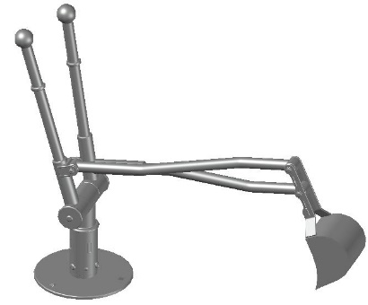
032622000 |  | Mobile sand digger
 | One-time maintenance
 | Check all screw connections; retighten, if necessary. |  |  | once,  approx. 4-5 weeks after installation

 | Recommended regular inspection and maintenance | once a week | twice per month | once a month | four times a year | twice a year | once a year
 | Clean playing sand
 | Check cleanliness of playing and safety area. Remove any foreign object
 | Check sheet metal and front edge protection of the bucket for wear, replace, if necessary.
 | Check tightness of stand construction: stability of (vertical) posts or supports, retighten screw connections, if necessary.
 | Check further structural components for wear and tightness; retighten, if necessary and replace defective parts.
 | Check bearings and/or joints for tight fixing and easy-running function, replace or grease, if necessary.

Please note: The above-mentioned maintenance intervals only have recommendatory character.
They must necessarily be adapted to the local circumstances of each playground (frequency of use, social setting, risk and frequency of vandalism etc.).

